Electronic packaging
Simplified

Through-Hole vs Surface mount

When it comes to packaging in electronics, you will be using either through-hole or surface mount. This is further defined by individual specific sizes of the individual components for example ¼ watt vs ½ watt resistors are two physically different sizes despite both having leads that mount through the board.

Through-Hole
This image shows a few different examples of through-hole componentry or packages. It is important to note that as the name suggests these devices go “Through the holes (aka via’s) in the board”. Here we have several resistors, capacitors and fuses.

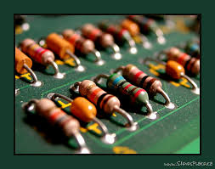

Here we see an illustration that shows how the through-hole component is inserted into the circuit board.

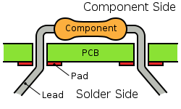

Below are some more examples of through-hole componentry
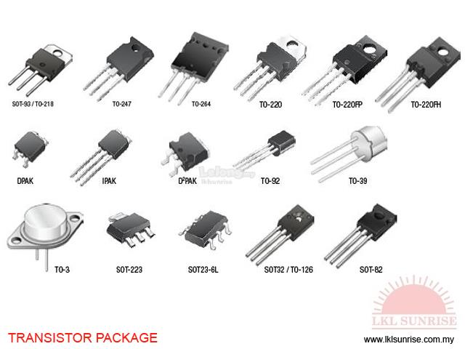

The image below shows different through-hole packages for IC’s

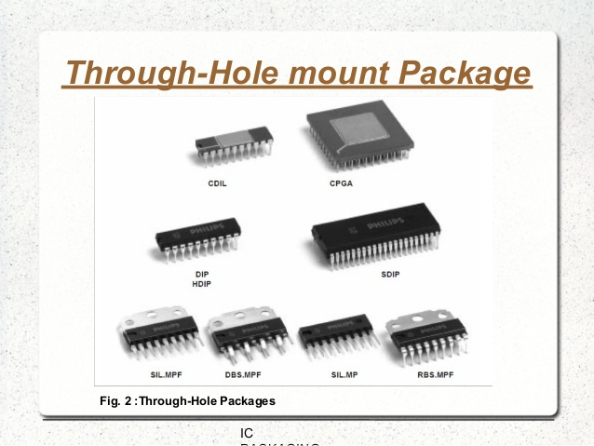

Surface mount

Surface mount packages as the name suggests mount only to one side of a circuit board. They sit on either the top or bottom of the circuit board. Their pins do NOT go through or penetrate the board.

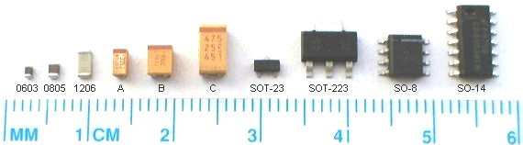
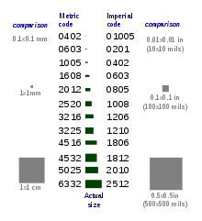

This image shows many different types of Surface Mount components mounted to the Top layer of the circuit board.

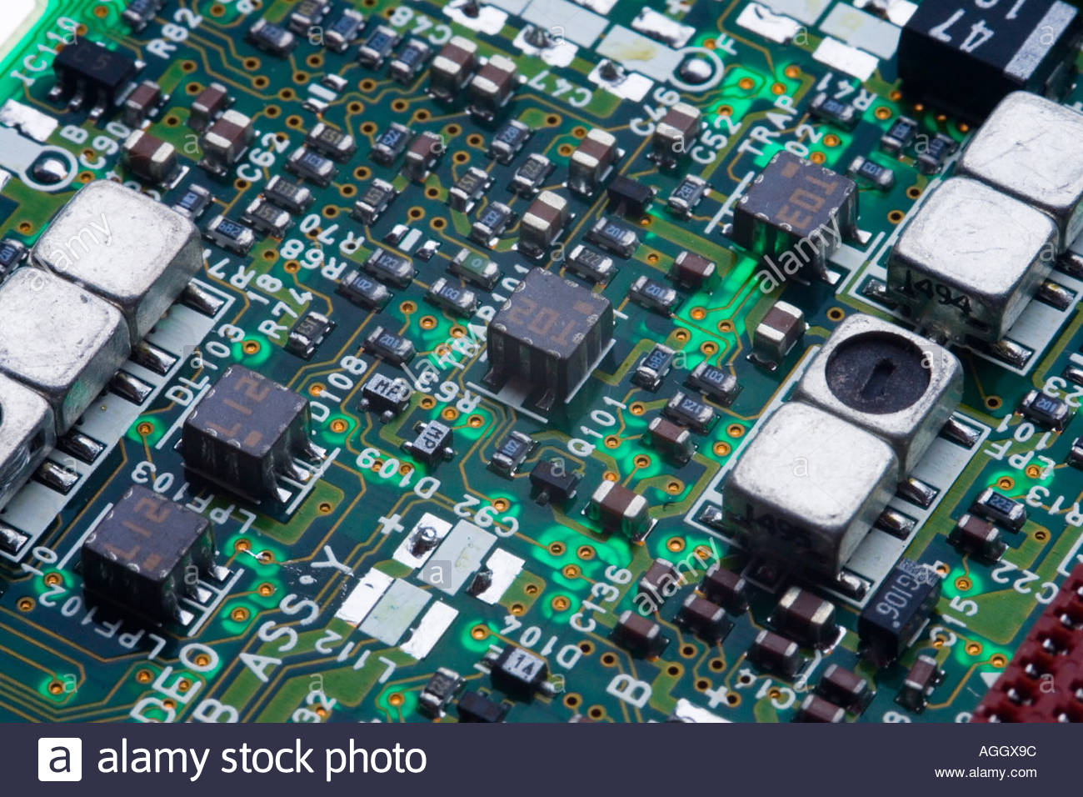

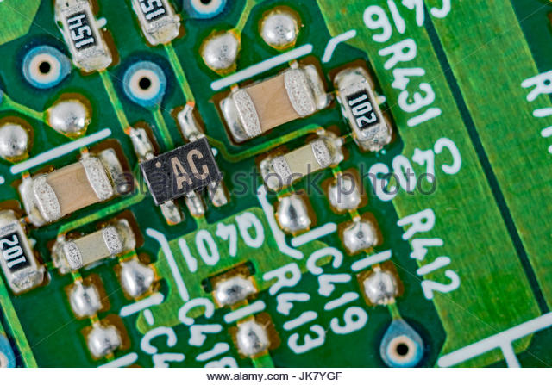

This reference document was created for SERC (Student Electronic Resource Center)
JL – 02-04-2019

